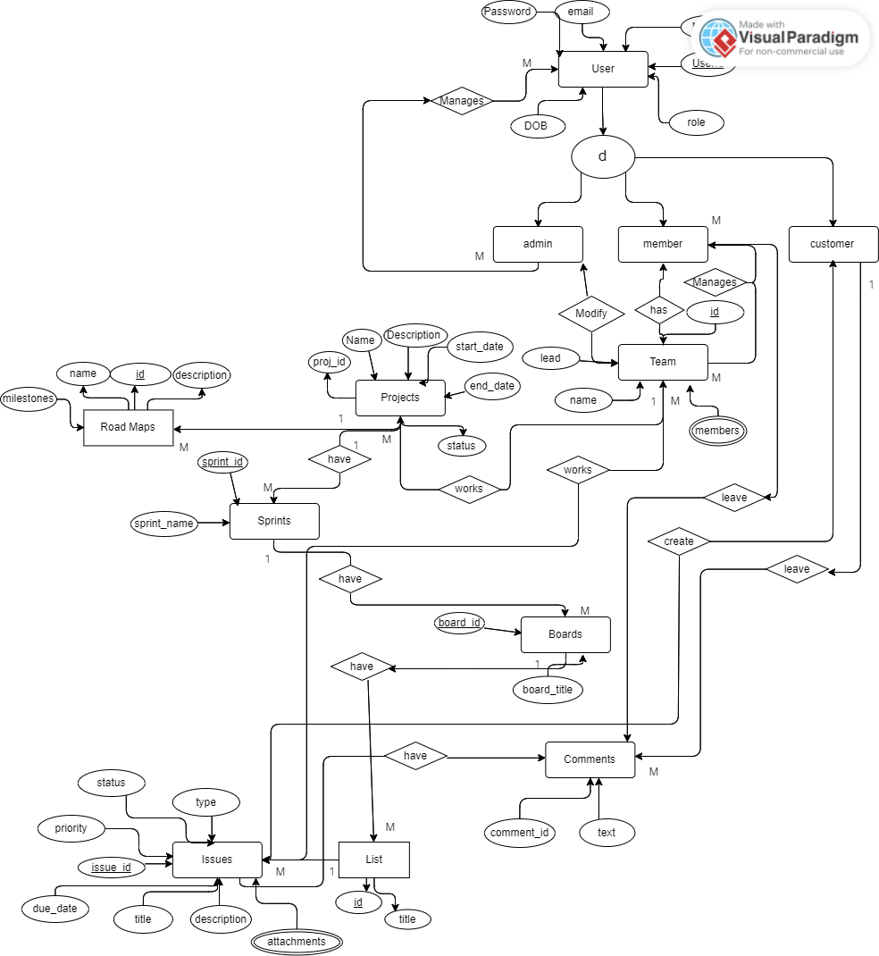

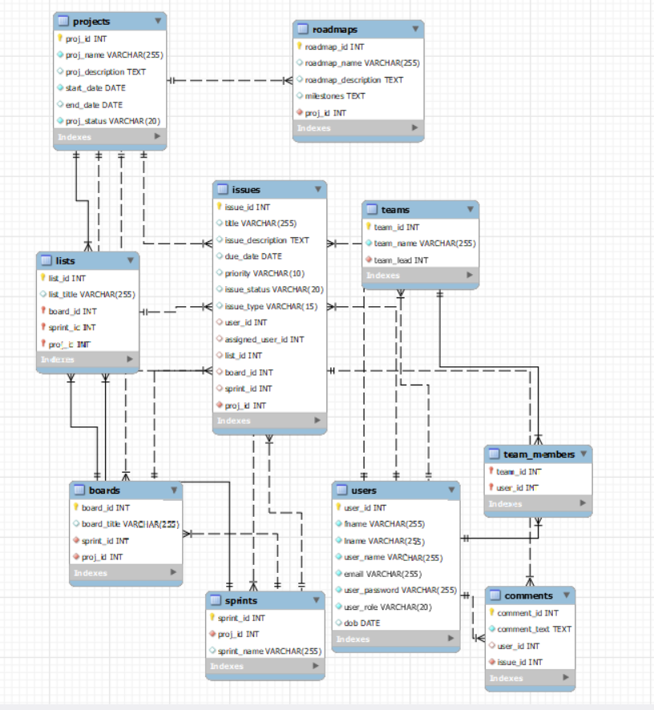

**Table Descriptions**

**Users**

|  |  |  |  |
| --- | --- | --- | --- |
| **Attribute Name** | **Data Type** | **Constraint** | **Example Data** |
| user_id | INT | PRIMARY KEY, auto_increment | 1 |
| fname | VARCHAR(255) | NOT NULL | John |
| lname | VARCHAR(255) | NOT NULL | Doe |
| email | VARCHAR(255) | UNIQUE, NOT NULL | [john@example.com](mailto:john@example.com) |
| user_password | VARCHAR(255) | NOT NULL | ******** |
| user_role | VARCHAR(20) | CHECK (user_role IN ('Admin', 'Customer', 'Team Member')), NOT NULL | Admin |
| dob | DATE |  | 1990-05-18 |

**Teams**

|  |  |  |  |
| --- | --- | --- | --- |
| **Attribute Name** | **Data Type** | **Constraint** | **Example Data** |
| team_id | INT | PRIMARY KEY, auto_increment | 1 |
| team_name | VARCHAR(255) | NOT NULL | Development Team |
| team_lead | INT | NOT NULL | 1 |

**Team Members**

|  |  |  |  |
| --- | --- | --- | --- |
| **Attribute Name** | **Data Type** | **Constraint** | **Example Data** |
| team_id | INT | NOT NULL | 1 |
| user_id | INT | NOT NULL | 1 |

**Sprints**

|  |  |  |  |
| --- | --- | --- | --- |
| **Attribute Name** | **Data Type** | **Constraint** | **Example Data** |
| sprint_id | INT | PRIMARY KEY, auto_increment | 1 |
| sprint_name | VARCHAR(255) |  | Sprint 1 |
| proj_id | INT | NOT NULL | 1 |

**Road Maps**

|  |  |  |  |
| --- | --- | --- | --- |
| **Attribute Name** | **Data Type** | **Constraint** | **Example Data** |
| roadmap_id | INT | PRIMARY KEY, auto_increment | 1 |
| roadmap_name | VARCHAR(255) |  | Roadmap A |
| roadmap_description | TEXT |  | Lorem ipsum... |
| milestones | TEXT |  | Milestone 1, Milestone 2 |
| proj_id | INT | NOT NULL | 1 |

**Projects**

|  |  |  |  |
| --- | --- | --- | --- |
| **Attribute Name** | **Data Type** | **Constraint** | **Example Data** |
| proj_id | INT | PRIMARY KEY, auto_increment | 1 |
| proj_name | VARCHAR(255) | NOT NULL | Project A |
| proj_description | TEXT |  | Lorem ipsum... |
| start_date | DATE | NOT NULL | 2023-01-01 |
| end_date | DATE |  | 2023-06-30 |
| team_id | INT |  | 1 |
| proj_status | VARCHAR(20) | CHECK (proj_status IN ('Active', 'In-Active', 'Completed')), NOT NULL | Active |

**Project Teams**

|  |  |  |  |
| --- | --- | --- | --- |
| **Attribute Name** | **Data Type** | **Constraint** | **Example Data** |
| proj_id | INT |  | 1 |
| team_id | INT |  | 1 |

**Lists**

|  |  |  |  |
| --- | --- | --- | --- |
| **Attribute Name** | **Data Type** | **Constraint** | **Example Data** |
| list_id | INT | PRIMARY KEY, auto_increment | 1 |
| list_title | VARCHAR(255) |  | List A |
| board_id | INT | NOT NULL | 1 |

**Issues**

|  |  |  |  |
| --- | --- | --- | --- |
| **Attribute Name** | **Data Type** | **Constraint** | **Example Data** |
| issue_id | INT | PRIMARY KEY, auto_increment | 1 |
| title | VARCHAR(255) |  | Issue 1 |
| issue_description | TEXT |  | Lorem ipsum... |
| due_date | DATE |  | 2023-05-30 |
| priority | VARCHAR(10) | CHECK (priority IN ('High', 'Medium', 'Low')) | High |
| issue_status | VARCHAR(20) | CHECK (issue_status IN ('Open', 'In-Progress', 'Resolved')) | Open |
| issue_type | VARCHAR(15) | CHECK (issue_type IN ('Bug', 'Task', 'Feature', 'Improvement')) | Bug |
| list_id | INT | NOT NULL | 1 |
| customer_id | INT | NOT NULL | 1 |
| proj_id | INT |  | 1 |
| teammember_id | INT |  | 2 |

**Comments**

|  |  |  |  |
| --- | --- | --- | --- |
| **Attribute Name** | **Data Type** | **Constraint** | **Example Data** |
| comment_id | INT | PRIMARY KEY, auto_increment | 1 |
| comment_text | TEXT | NOT NULL | Lorem ipsum... |
| user_id | INT |  | 1 |
| issue_id | INT | NOT NULL | 1 |

**Boards**

|  |  |  |  |
| --- | --- | --- | --- |
| **Attribute Name** | **Data Type** | **Constraint** | **Example Data** |
| board_id | INT | PRIMARY KEY, auto_increment | 1 |
| board_title | VARCHAR(255) |  | Board A |
| sprint_id | INT | NOT NULL | 1 |

**Project Features**

**Admin**:

* Can View Projects
* Can Generate Reports
* Can Create New Users
* Can Delete Users
* Can Set User Privileges
* Can Create Teams
* Add Members to Teams
* Remove Members from Teams

**Manager:**

* Setup Projects
* Create New Sprints
* Create New Boards
* Create New Lists
* Assign Tasks
* Manage Tasks

**(Managers are a special case of Team Members)**

**Team Member:**

* Can View Assigned Tasks
* Can View Assigned Projects

**Customers:**

* Can Create New Issues
* Can Manage Issues